Overview: -

One of the most iconic engineering structures in Sydney, opened to traffic in 1932. The bridge and its railway approaches however had taken more than a decade to build. Many of the important step, especially in design and specification, were made in 1923, after tenders were first called in 1921. This presentation will look at the events and personalities who made those decisions and the early works undertaken. John Bradfield built the Harbour Bridge and there is justifiable controversy as to whether he designed it, especially in the more detailed engineering aspects.
What is not so well known is that he managed public opinion and government processes to ensure that the project would proceed. His first construction was the team which he gathered around himself to further his aims. They were often very young, sometimes not formally qualified in engineering and if they were, locally trained. They answered to him directly and he gave them every opportunity to lead and excel.

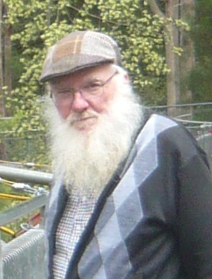
Presenter - Bill Phippen

Bill Phippen is a qualified civil engineer who late in his career moved into history and engineering heritage. He has had five books published – The Hawkesbury River Railway Bridges, By Muscle of Man and Horse, building the railway under Sydney 1916-1932, from Eddy Avenue to Menin Gate – the Great Sydney Station Honour Board, The Timber Truss Railway Bridges of NSW, and Steam at its Pinnacle – the photography of Norman Joseph Read. His current research effort is the centenary of the Sydney Harbour Bridge whose construction began in 1922.

The Hawkesbury River Railway Bridges received the Colin Crisp Award for documentation of heritage from Engineers Australia in 2019.

Bill was awarded an Order of Australia Medal in 2013 for service to people with disability through the charity Technical Aid to the Disabled. He is a Fellow of the Institution of Engineers Australia.
He has recently become a volunteer guide at the Australian National Maritime Museum and joined their speakers’ panel.

Detail

Date and Time:1100, Wednesday 13th. November 2024 (Sydney time)
Join Here

Please join us.

