The history of the Royal Australian Navy (RAN) and some history of the Harbour.
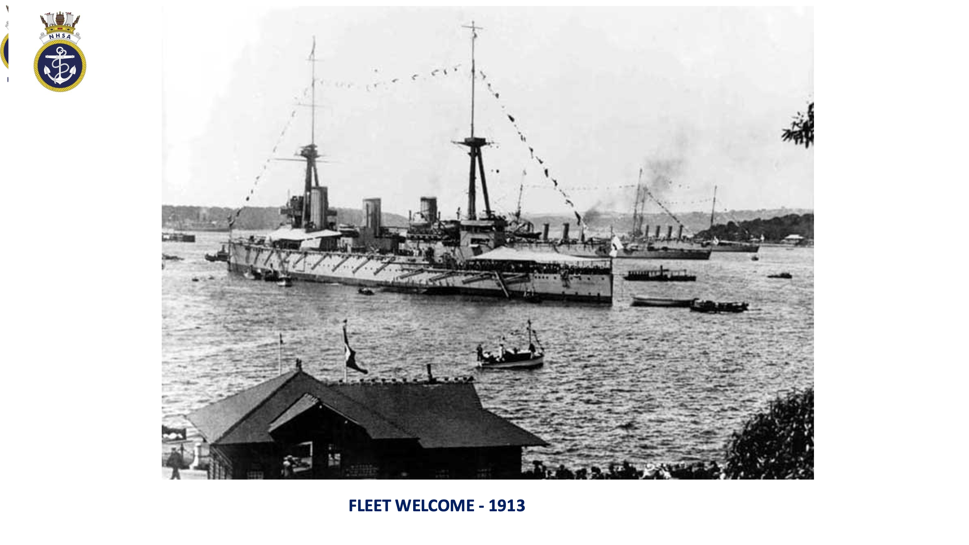
The protection of the colony in the early days by a Royal Navy squadron of ships. The Navy surveyed the Harbour and the NSW coast.

The formation of the RAN and the fleet entering the Harbour in 1913. HMAS AUSTRALIA
I, HMAS SYDNEY I, HMAS ENCOUNTER, HMAS MELBOURNE, HMAS WARREGO, HMAS PARRAMATTA and HMAS YARRA.
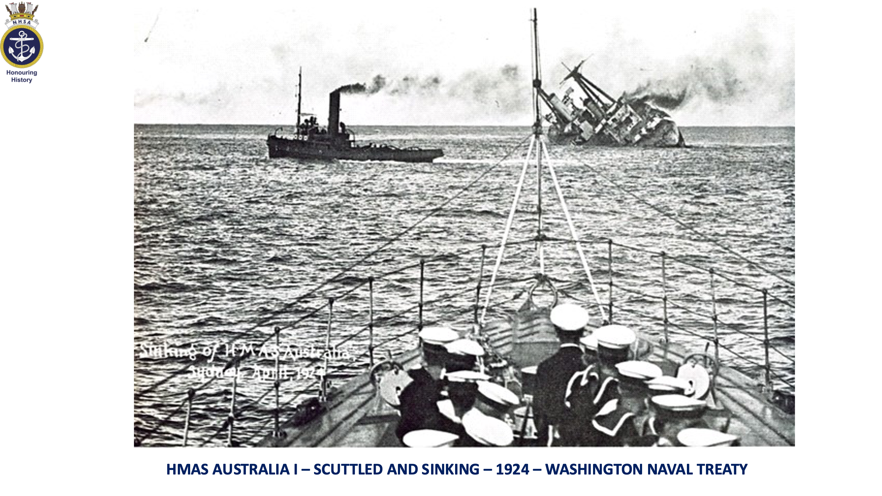

The story of HMAS AUSTRALIA I – our first flagship in WW I. HMAS AUSTRALIA was scuttled outside the heads as required by the Washington Navy Treaty.

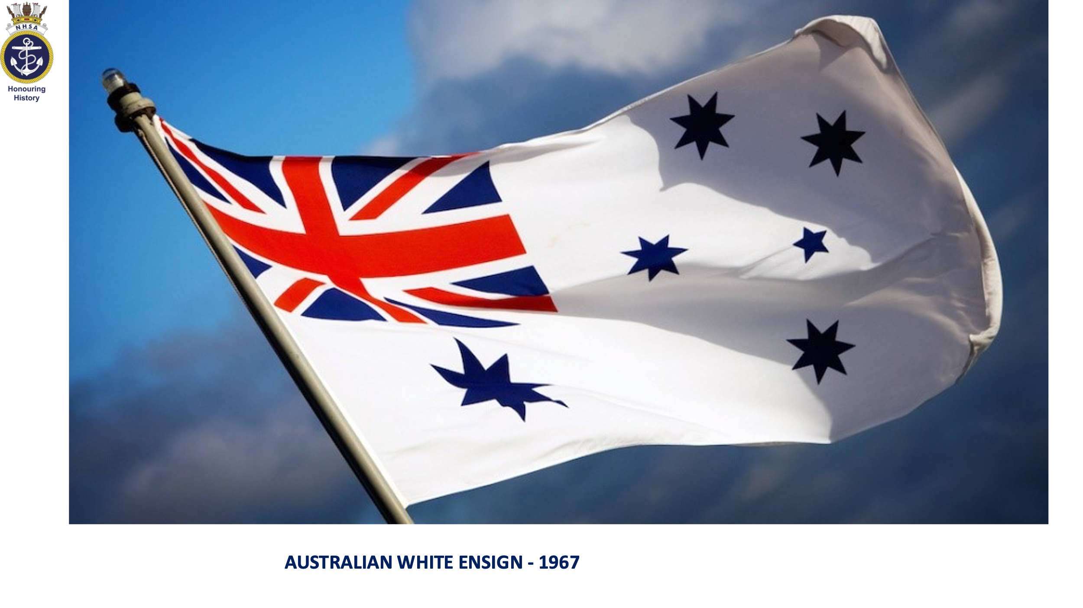
The role and motto of the RAN and the history of the white ensign which is flown by all RAN commissioned ships.

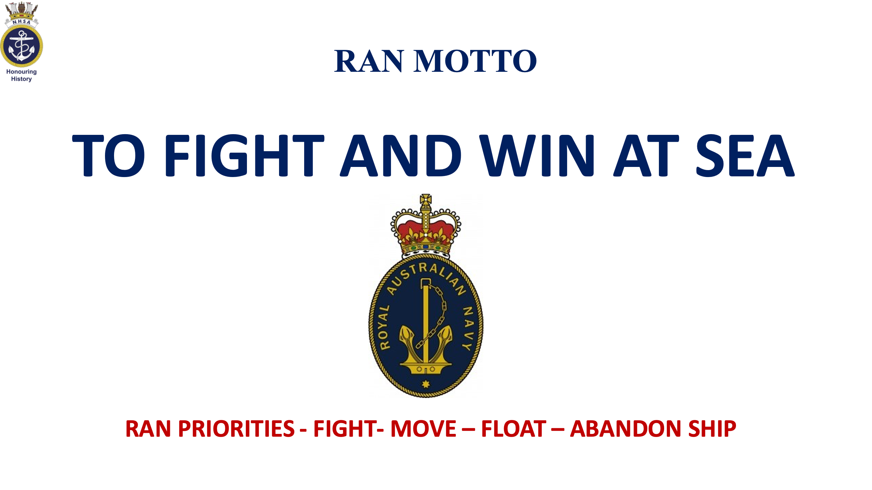

First mission, to capture German New Guinea during WW I.

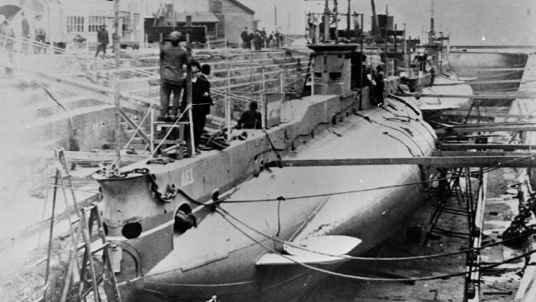

The story of our first submarines – AE1 and AE2. AE1 was a lost in the Rabual campaign with all 35 men and AE2 was scuttled in the Gallipoli campaign with the crew becoming POW’s.

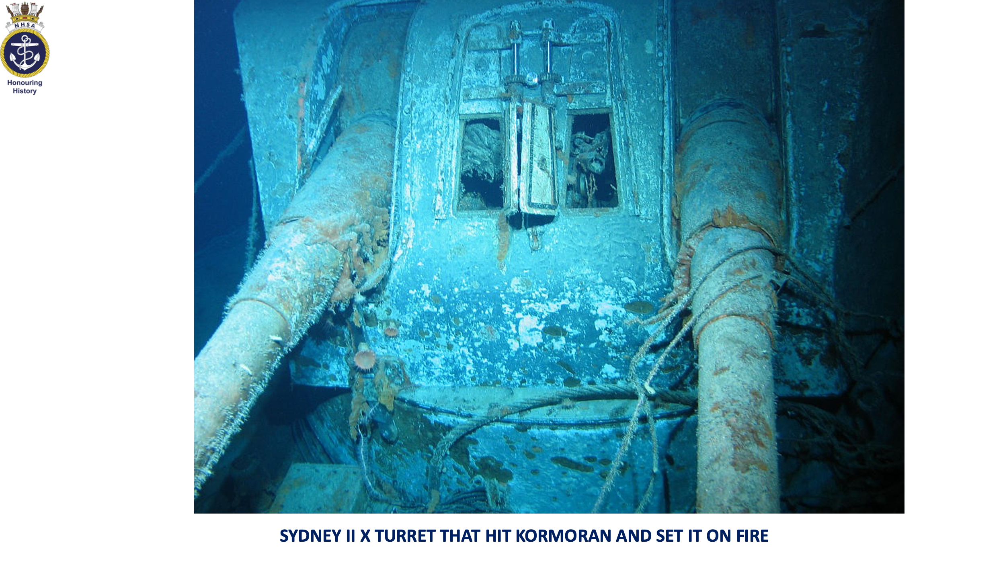
THE RAN’s first battle and first victory. The HMAS SYDNEY (I) SMS EMDEN battle in the Indian Ocean. EMDEN was severly damageed and run aground on an island.

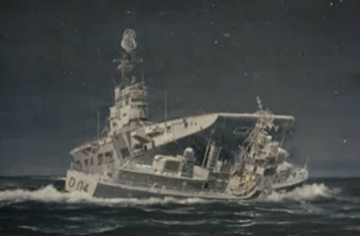
The SYDNEY II story. The pride of the RAN in early WW II having sunk an Italian cruiser. Lost off the West Australian coast with no survivors from a crew of 645. Sunk by the German raider KORMORAN which had disguised its guns.

The HMAS MELBOURNE HMAS VOYAGER collision. The only time in the history of Australia when it took two royal commisions to find out what really happened.

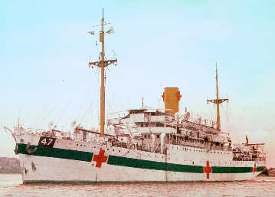
The finding of lost RAN ships to bring some closure to family and friends.

Ships found include HMAS SYDNEY II, AHS CENTAUR, the hospital ship sunk by a Japanes submarine and AE1 and AE2 submarines have been found.

